- Purpose
  - The purpose of this document is to describe the procedure for assembling the Recovery Tank on the Genesys Machine.
- Scope
  - This SOP applies to all equipment assembly team members. The process applies to the following machine ID’s:
EP50328EQS0600BE1200 – Recovery Tank Assembly (MSAS)
EP50290EQS0600BE1200 – Recovery Tank Assembly (G20)
- Responsibilities
  - The operations manager/supervisor is responsible for enforcing this SOP.
- Materials
  - The proper materials needed for this process are listed on the machine work order.
- Definitions

- Procedure
  - Start with a recovery tank (E28575 – MSAS / E28886 – G20).
  - Tap out the hole where the lid mounts using a 1 ½” tap. Align tap with hole slowly thread tap through the hole. When tap is in halfway back the tap off making sure it is level.
  - Take a PVC tube (E29577) and but it into a 4” piece. Verify there are no obstructions inside the tank (Note: if obstruction is present grind out the area impeding the tube from being placed). Press the tube into a barbed fitting (E29531). Thread the fitting into the appropriate location on the recovery tank.
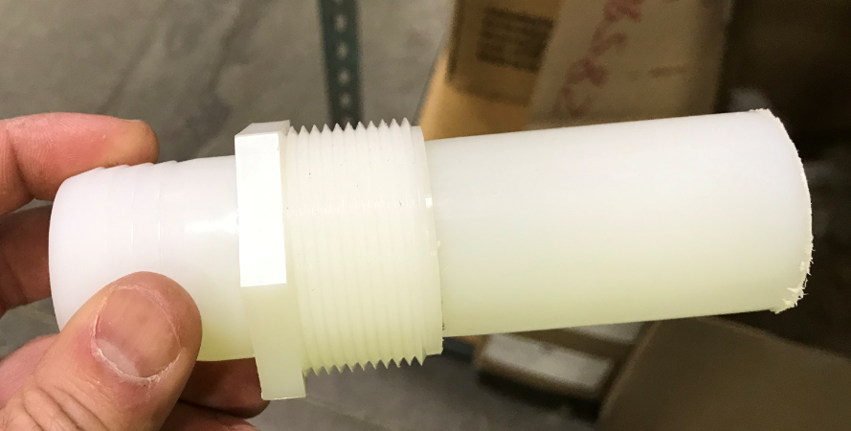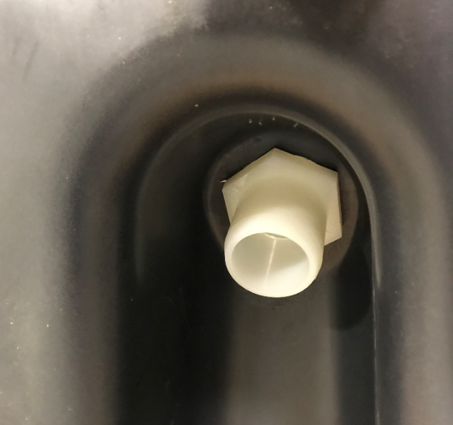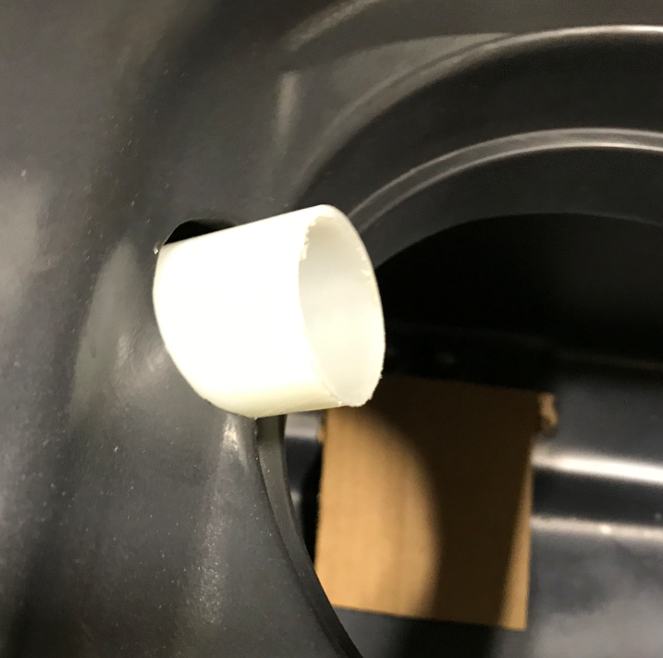

  - Take a float ball cage mount (E29562) and stick a gasket (E28607) onto the bottom side. Attach the mount to the tank using 2 hex bolts (E81089) and 2 washers (E28622).
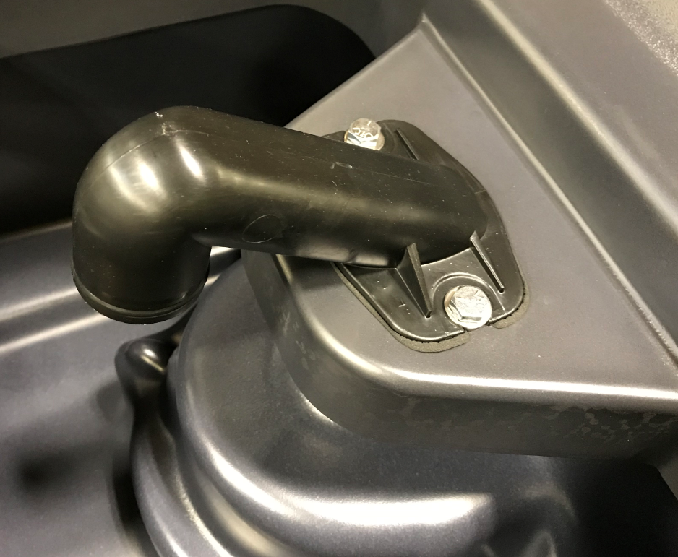
Gasket goes between tank and Mount
  - Put a float ball shut off (E29563) onto the end of the mount. Verify float balls are present. Attach it with a clamp (E28990). Position interlocked portion of the clamp under the gooseneck.
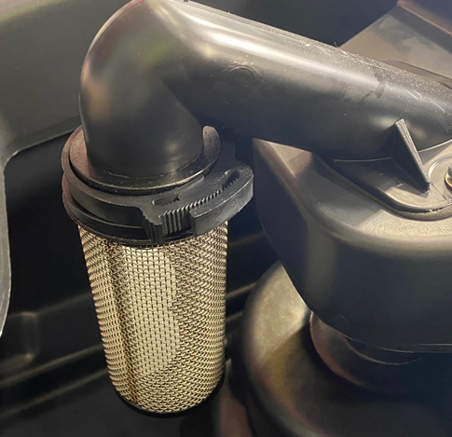

  - Place the vac assembly (Refer to SOP 107 for assembly instructions) into the pocket on the tank. -On the MSAS, place 3 spacers (E28850) between the bracket and the tank. Then use 3 washers (E28622) and 3 hex bolts (E81072) to attach the bracket.
-On the G20, attach the vac bracket with 3 washers (E28622) and 3 hex bolts (E81072).
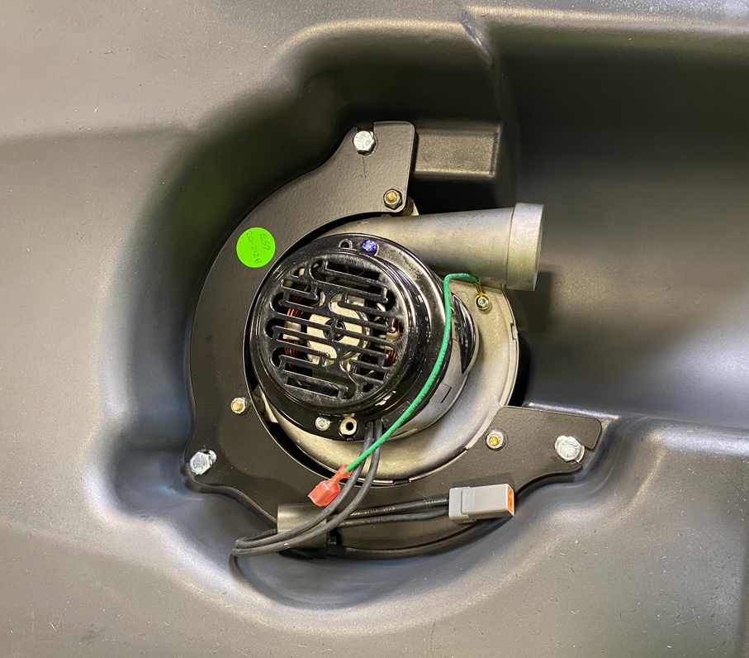
Spacers go between bracket and tank on the MSAS
  - Attach each of the 2 hinges (E28596) to the tank using 4 total flange bolts (E29569). Slide the hinges towards the back of the tank as shown.

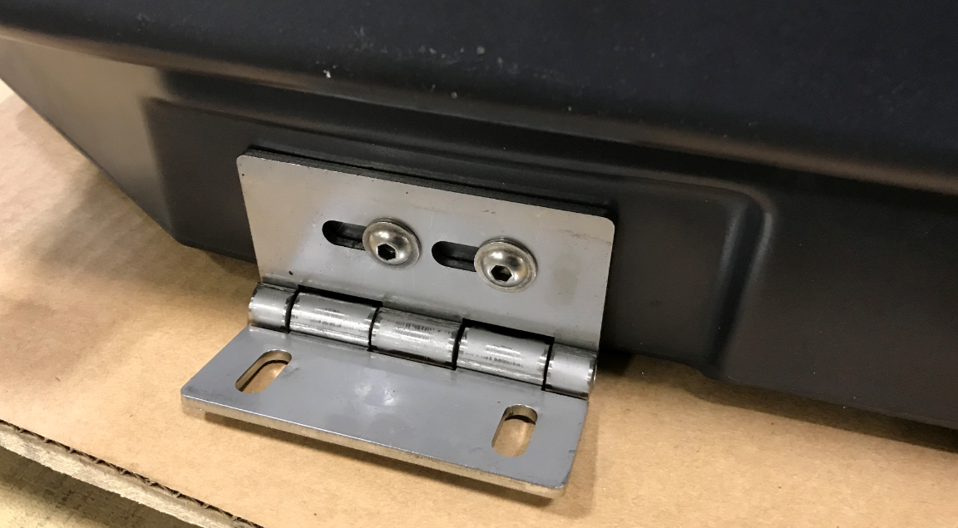

- References (optional section as needed)

- Training Guide

Functional Training Groups Requiring Training
Equipment Assembly Group

- SOP Change Control

Date of Change | Reason for Change
TBD | This is the first version of the S.O.P. hence there are no revisions to this document.
8/9/2021 | Remove the vac motor assembly portion. That is now its own SOP
11/2/2023 | Updated steps for current process.
3/31/2025 | Combined MSAS and G20 instructions.

Approvals

Submitter/Author Approval:__________________________________ Date:______________________

Management Approval:______________________________________ Date:______________________

QAU Approval:_____________________________________________ Date:______________________

